|  |  |
| --- | --- |
| **Sprint-1:**   * Data Collection * Data Preparation   **Sprint-2:**   * Data Exploration | **Sprint-3:**   * DashboardCreation   **Sprint-4:**   * Report Creation * Story Creation |

**Project Development Phase Delivery of Sprint-3**

|  |  |
| --- | --- |
| **Date** | 24 NOV 2022 |
| **TeamID** | PNT2022TMID51381 |
| **ProjectName** | Analytics for Hospitals' Health-Care Data |

**Project Development Phase:**

**Dashboard Creation**

**TAB-1**

* **City_Code_Hospital colored by Hospital_type_code**
* **Available Extra Rooms in Hospital by Department**

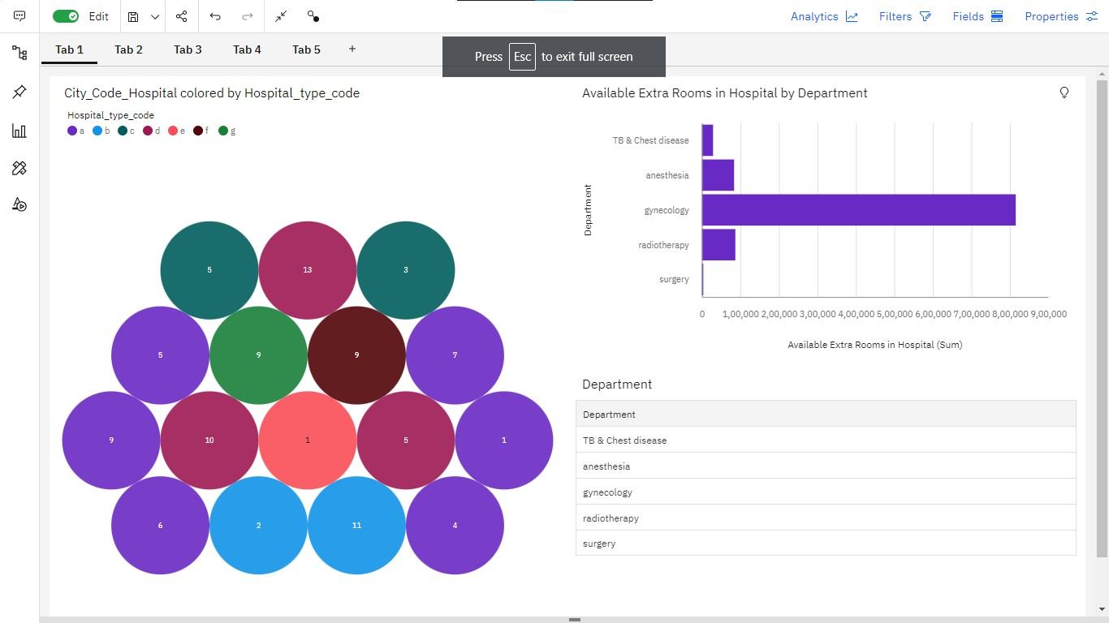

# TAB - 2

❑**Department, Ward_Type and Ward_Facility_Code**

❑**City_Code_Hospital for Hospital_region_code**

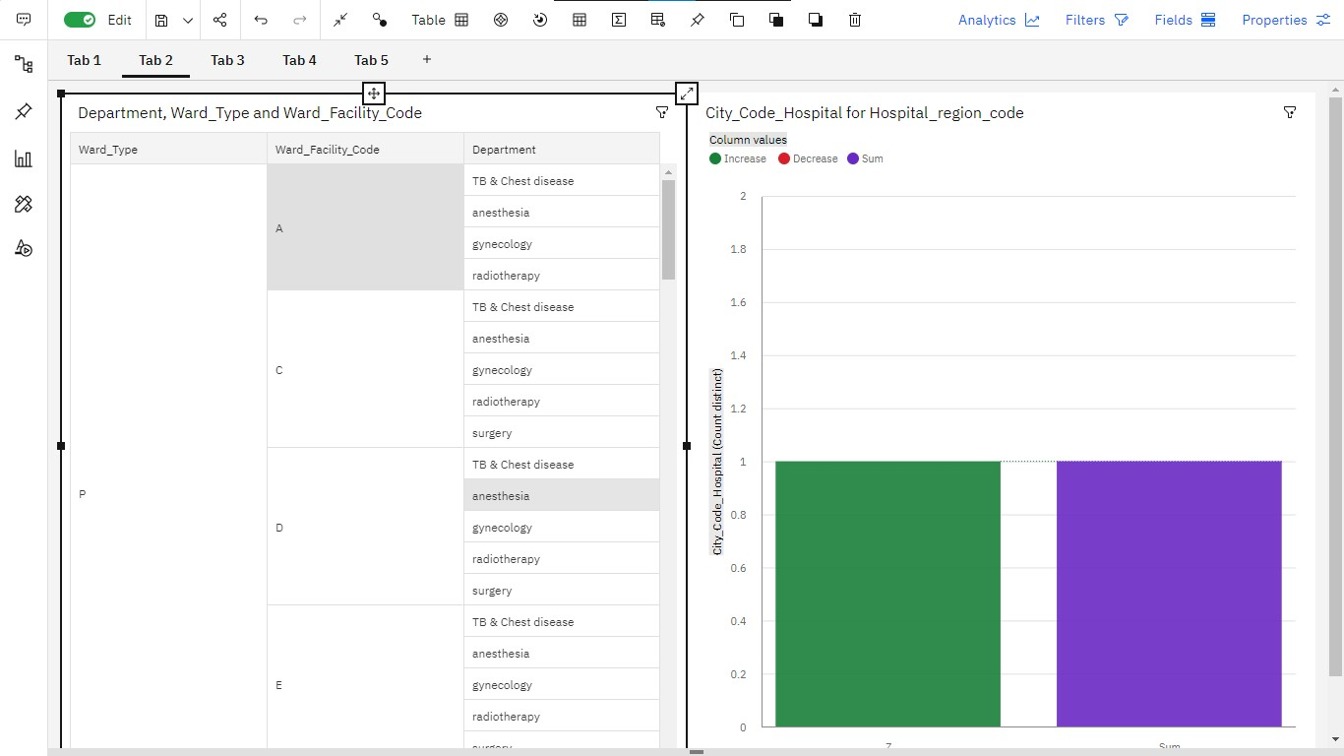

# TAB - 3

❑**Severity of Illness by Severity of Illness**

❑**Admission_Deposit by Age**

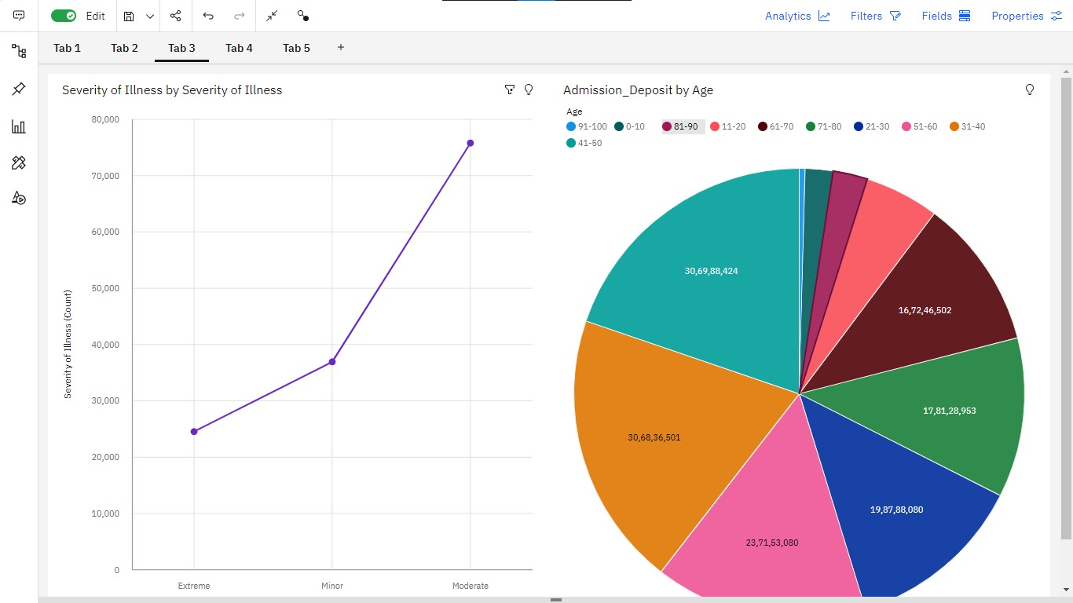

# TAB- 4

❑**Available Extra Rooms in Hospital**

❑**Bed Grade by City_Code_Patient colored by Department**

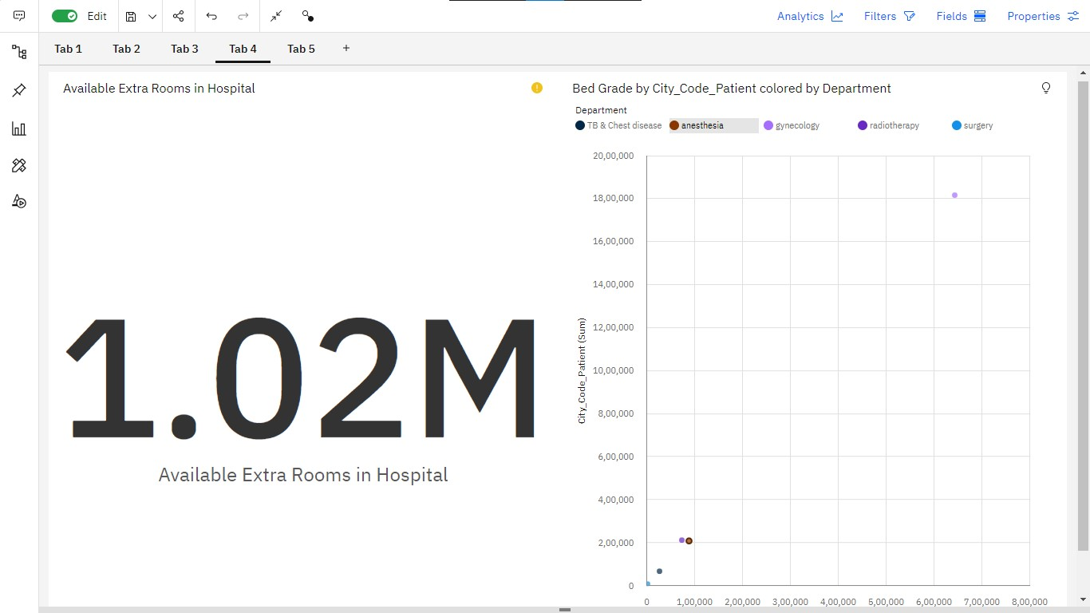

# TAB - 5

❑**Ward_Type by Department**

❑**Severity of Illness to Age**

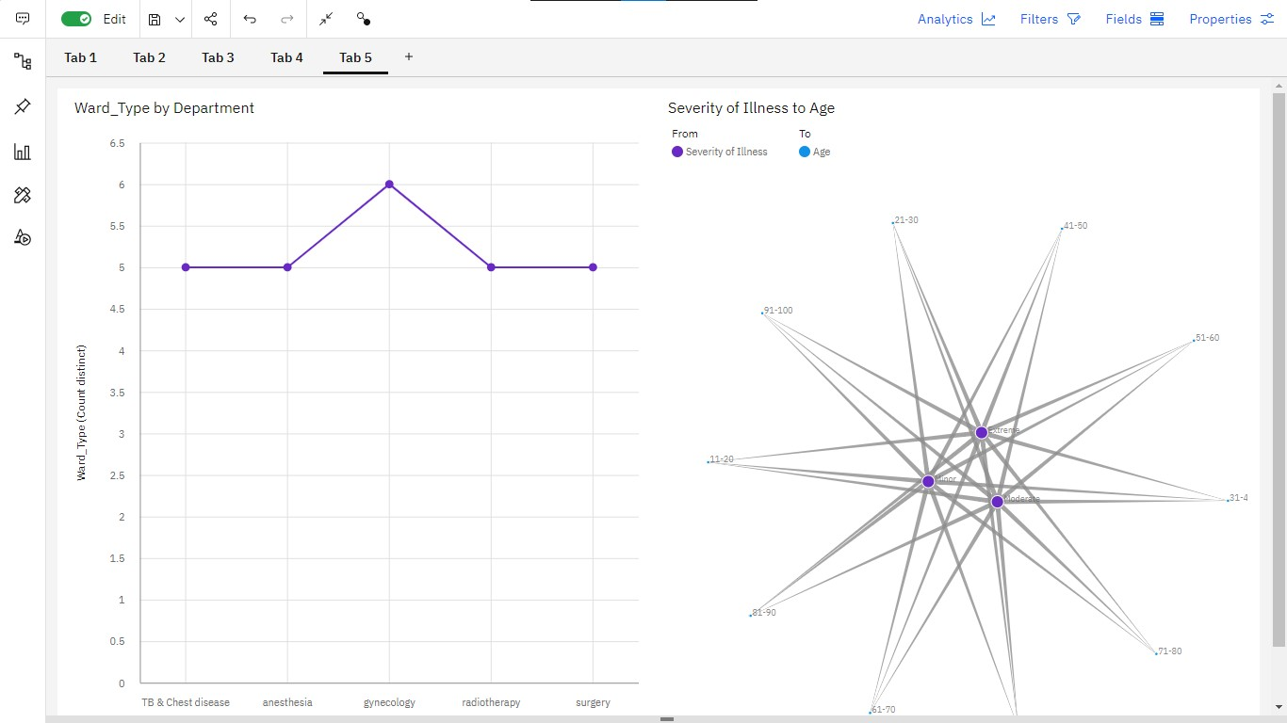

# TAB - 6

❑**patientid by Department colored by**

**Hospital_region_code**

❑**Ward_Type by Bed Grade**

❑**Department for City_Code_Hospital**

❑**Hospital_region_code and Ward_Type for visitors with Patient colored by City_Code_Patient**

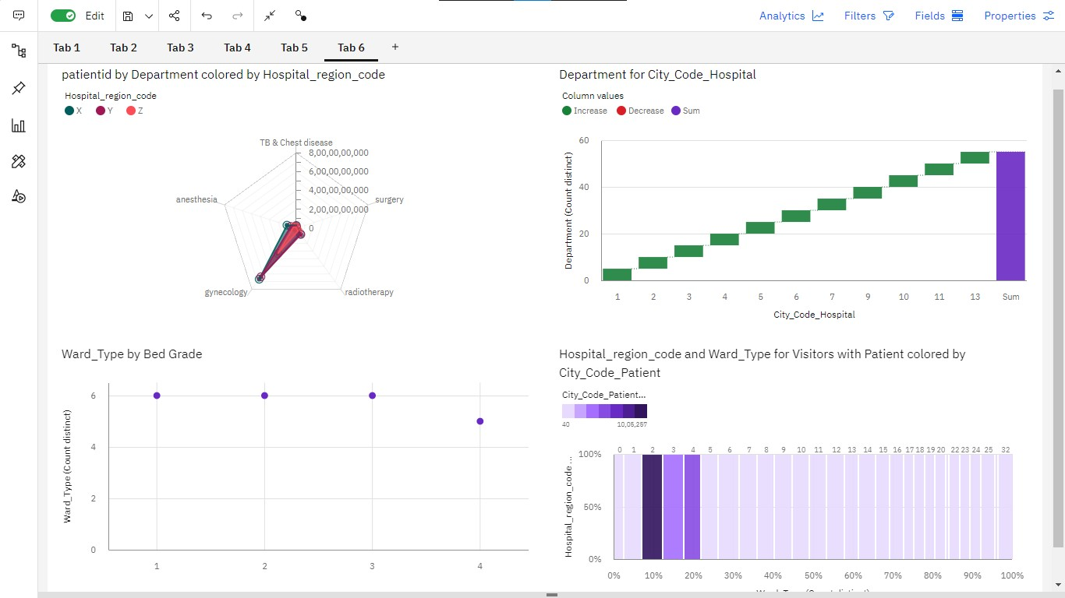

**Prepared data link :**

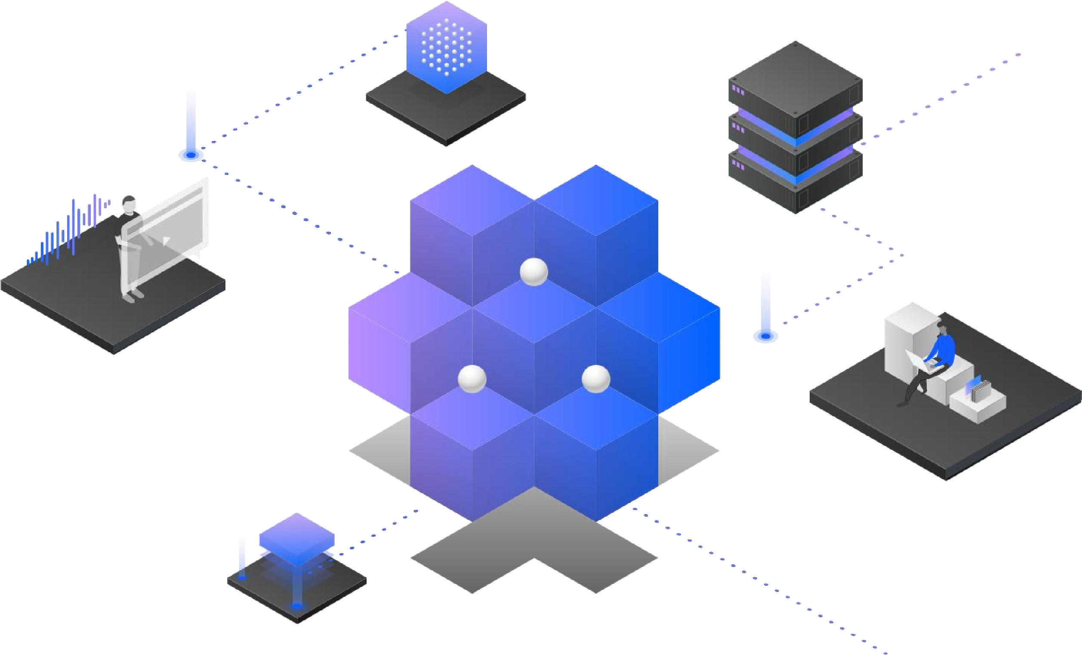https://us1.ca.analytics.ibm.com/bi/?perspective=da shboard&pathRef=.my_folders%2Fsprint-

3&action=view&mode=dashboard&subView=model0

00001845bf68dae_00000000